**Authentication:**

Who am I?

**Authorization:**

What we can do inside our application or entitlement.

Need to 3 Jars

1. Spring-security-web
2. Spring-security-config
3. Commons-logging -> Façade to logging framework of underlying logging mechanism in application

**web.xml** entry

Context Loader Listener and Application entry point.

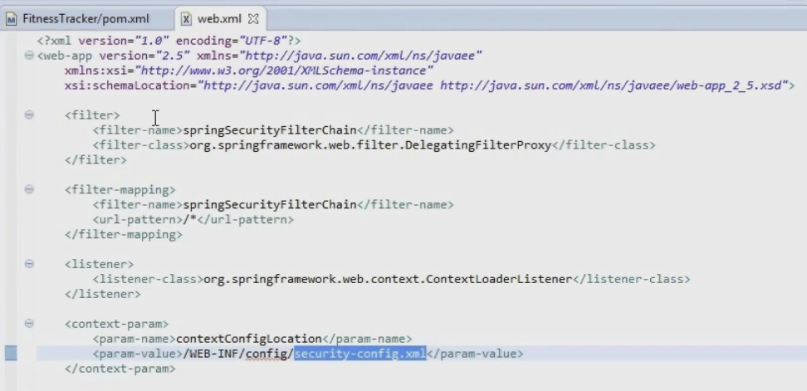

Save in same path of dispatcher servlet like WEB-INF or WEB-INF/config or may be src/main/resources (but then use class path)

**Security Config xml (for in memory authentication)**

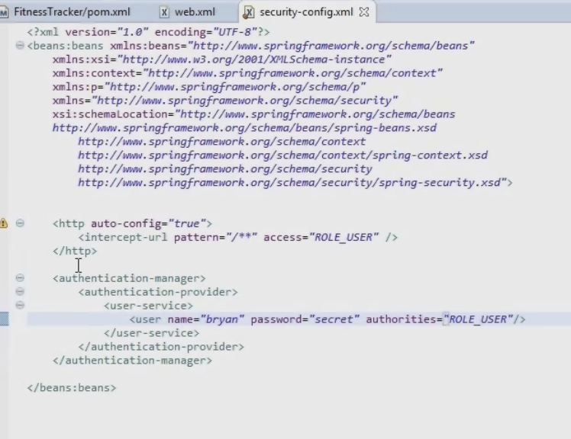

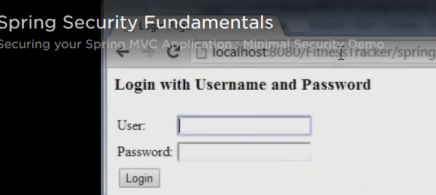

Two tables: one for authentication and other for authorization

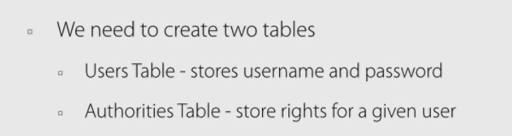

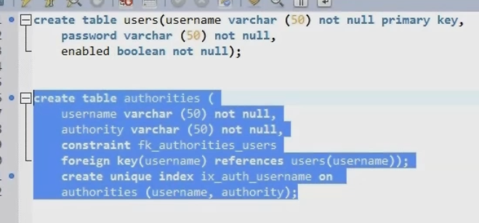

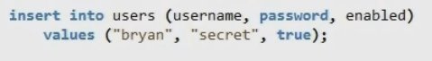

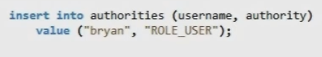

Pom.xml entry for dependency

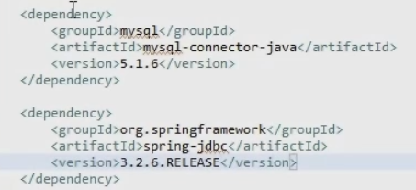

Modify security-config.xml to add the database driver like below

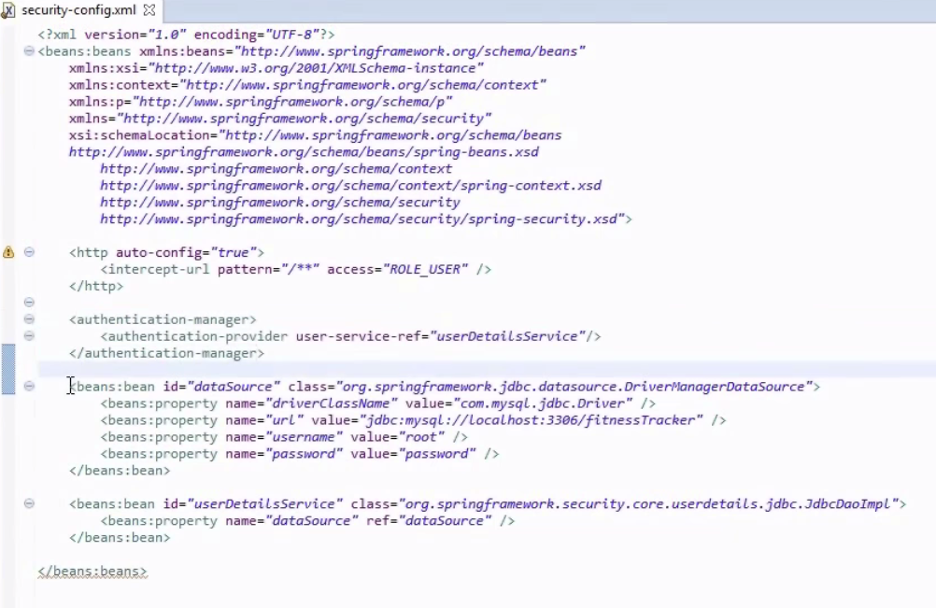

OR

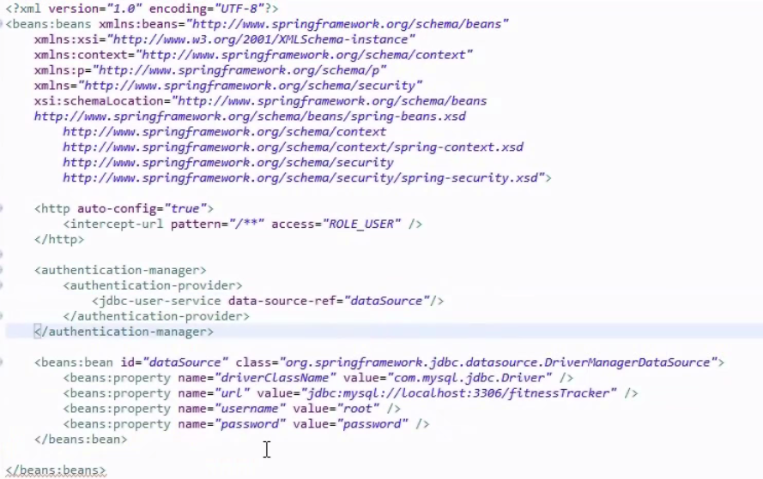

Client Integration

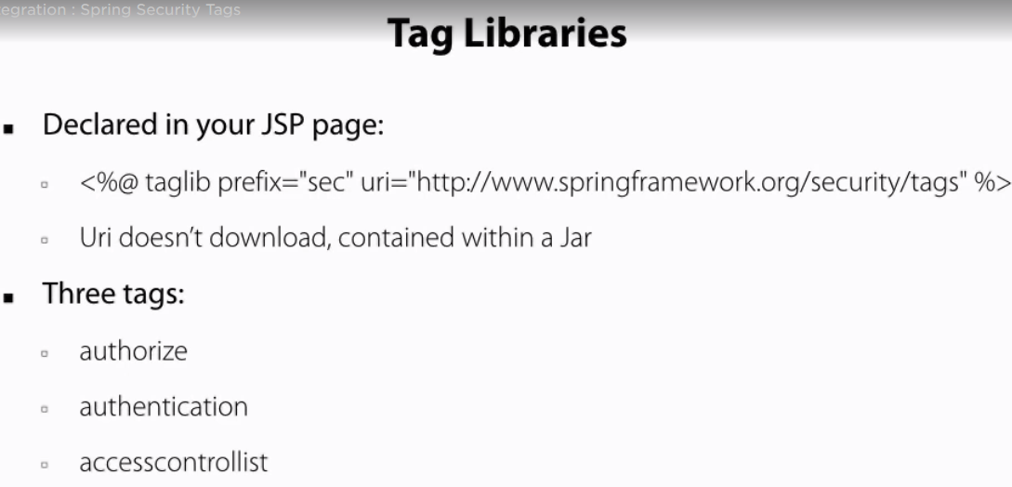

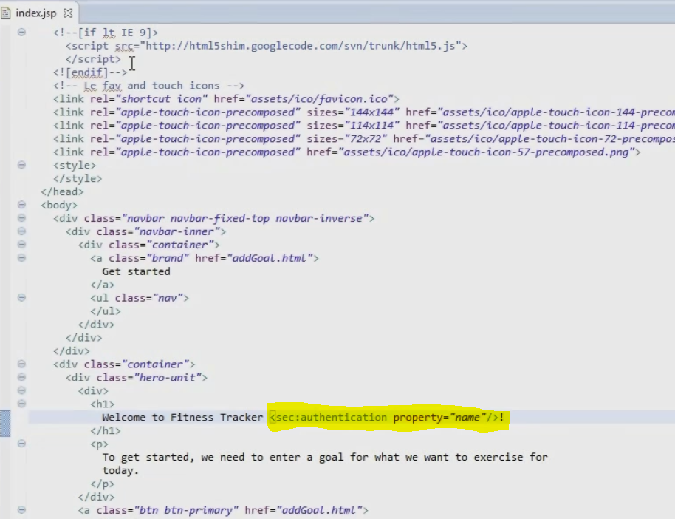

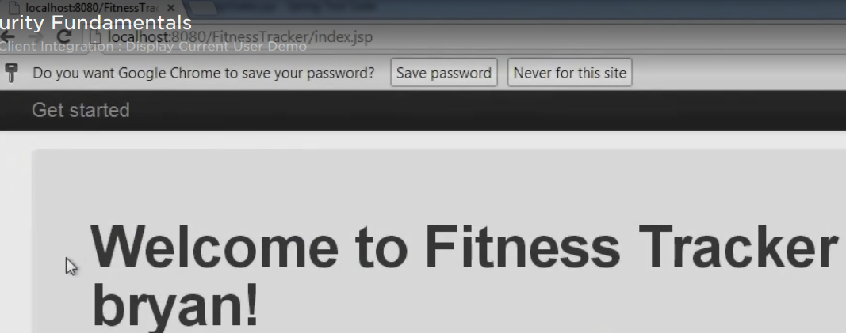

“Bryan “name appeared dynamically

Authorization Tags

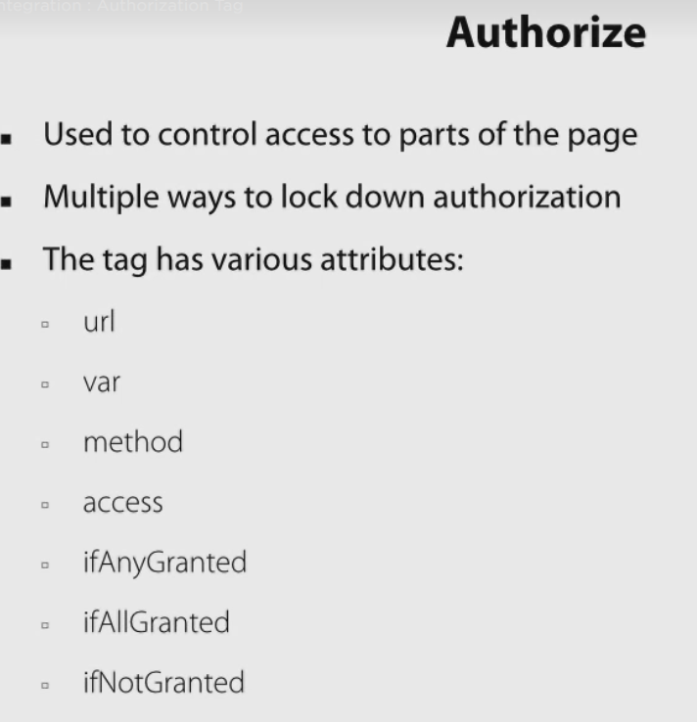

Example

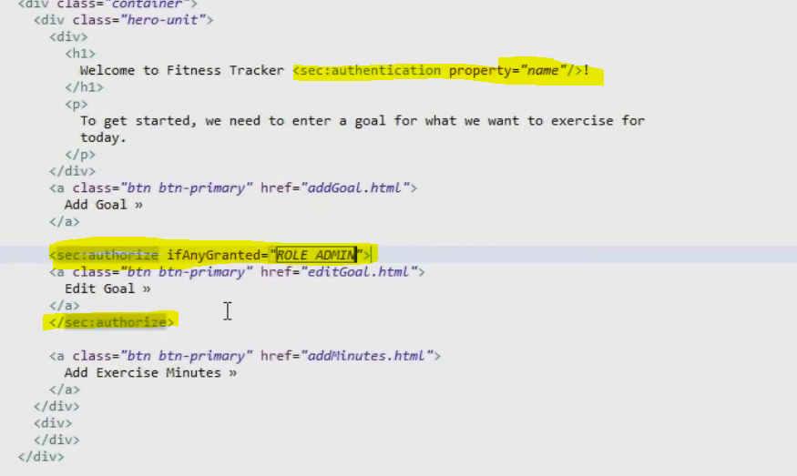

New button “editGoal” will appear only for admin user.

Add new user Chris as user and admin, user also is required as only user is allowed to login to application, please verify the security-config.xml

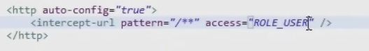

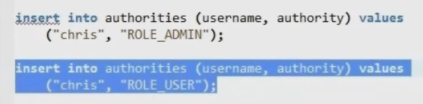

Now Chris will be able to login to application and edit button also will be visible as he is also admin. We can also change the xml config to add multiple access by comma separated, but modifying db is the good practice.

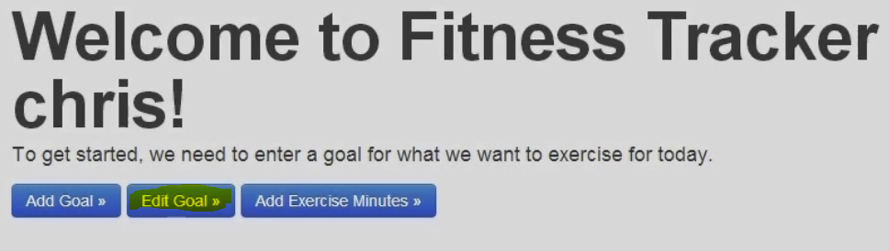

If access is denied then we will get 403 error codes.

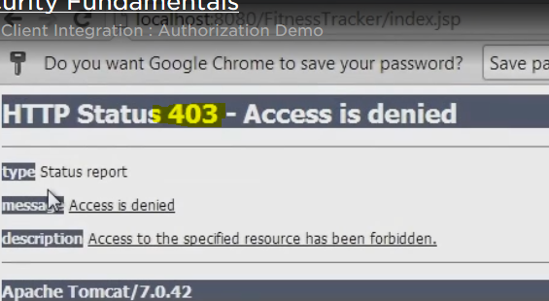

**Passwords**

**MD5 Hash**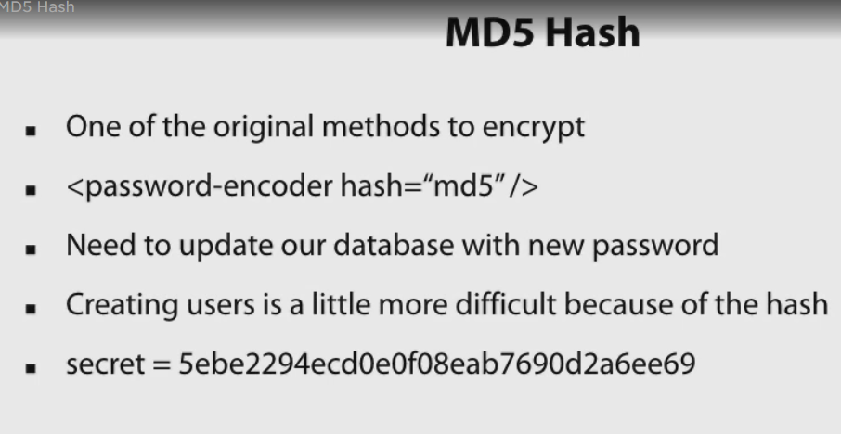

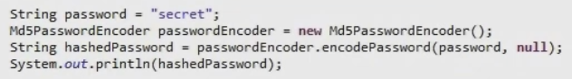



Update security-config.xml to 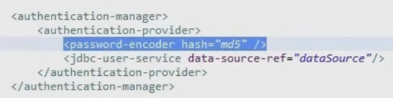

**BCrypt (better than MD5 as spring suggest)**

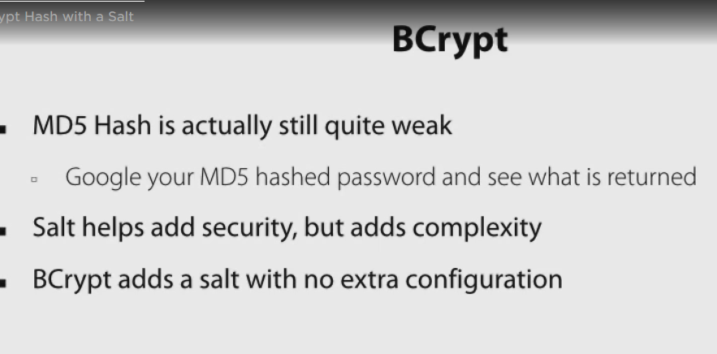

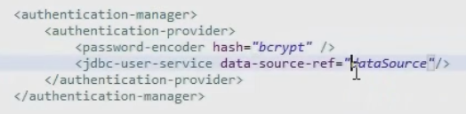

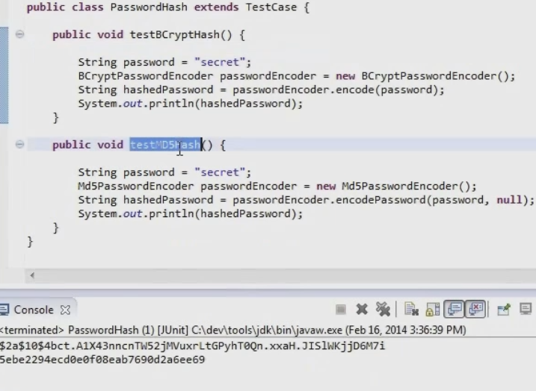

Spring Security login page can be customized, basic authentication can still be used for protecting web services.

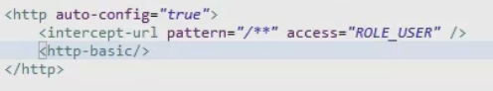

Above http-basic will allow us to use the basic one provided by spring

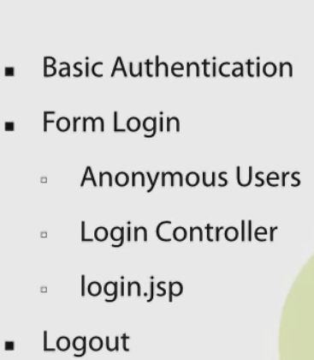

Access control using expressions

